DEMUX 1:4
module jay(
input din,
input s1, s0,
output reg y0, y1, y2, y3
);
always @(*) begin
y0 = 0;
y1 = 0;
y2 = 0;
y3 = 0;
if (s1 == 0 && s0 == 0)
y0 = din;
else if (s1 == 0 && s0 == 1)
y1 = din;
else if (s1 == 1 && s0 == 0)
y2 = din;
else
y3 = din;
end
endmodule

OUTPUT
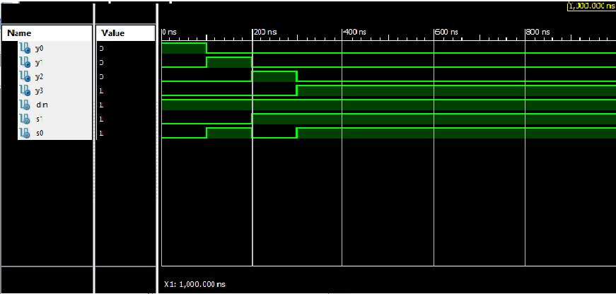
VERILOG TEST FIXTURE
module HNN;
reg din;
reg s1;
reg s0;
wire y0;
wire y1;
wire y2;
wire y3;
jay uut (
.din(din),
.s1(s1),
.s0(s0),
.y0(y0),
.y1(y1),
.y2(y2),
.y3(y3)
);
initial begin
// Initialize Inputs
din = 1;
s1 = 0;
s0 = 0;
#100;
din = 1;
s1 = 0;
s0 = 1;
#100;
din = 1;
s1 = 1;
s0 = 0;
#100;
din = 1;
s1 = 1;
s0 = 1;
#100;
end
endmodule

